Jennifer Ivanoff
CEP 811
StAIR: Project Report
I teach high school students with special needs. Most of my students have disabilities in reading and writing. My students have individualized education program (IEP) reading and writing goals. My students tend to have difficulties writing papers for all of their academic classes as well as mine. Writing is an essential part of school and post secondary work. To address my student’s needs I created a StAIR project on six writing traits in hopes of improving my students writing abilities. This information not only meets my students IEP goals, but also meets North Carolina competency goal 6, the learner will apply conventions of grammar and language usage.
My StAIR project address the six writing traits; ideas, organization, voice, word choice, sentence fluency, and conventions. I wanted to create a resource that my students could reference independently. To help my students guide their own learning I created this StAIR project using Microsoft PowerPoint with buttons and custom actions in kiosk mode.
I know that my students get distracted easily and need information to be presented in a direct consistent manner. To address this issue I created slides that are consistence in format and colors. The slides are simple and have one or two pictures to help my students associate each image with a particular trait. For my struggling readers I added audio to each slide. All my students have to do is click on the microphone icon to hear content from the slide as well as a way to connect the image to each trait.
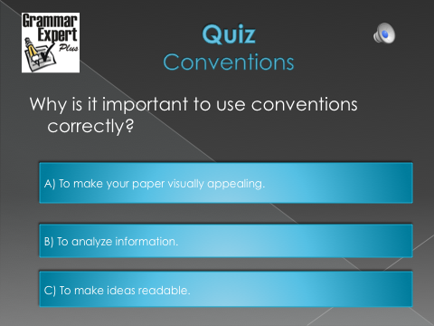
Direct instructional is the main strategy that I used when creating this project. Research has proven that students with disabilities need consistency and direct instruction when they are first learning material. I addressed them in my project. The instructional design of my StAIR presents information in a logical manner, presents information in small groups, and provides immediate feedback. From the navigation menu each of the writing traits are divided into their own slides that provide more information on that particular traits. Thus, making it easier for the students to grasp and learn the information. Immediate feedback is presented after each quiz question. When a students answers the question correctly they are presented with a “Right On” slide and a “yeehaw” to let them know they are right. When my students do not answer the correctly they are presented with a “Try Again” slide with a thinking cap and a screeching break. For example, when students are presented with the question, “Why is it important to use conventions correctly?” like the slide to the right they have three different options. Each option is linked to a slide that will give immediate feedback to the way the students responds to the question. If the student answers correctly they are presented with the slide to the bottom left. If a student does not understand the information and answers the question incorrectly they are presented with the slide to the bottom right.
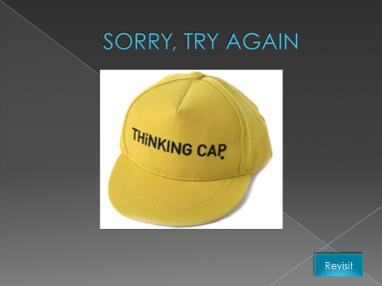
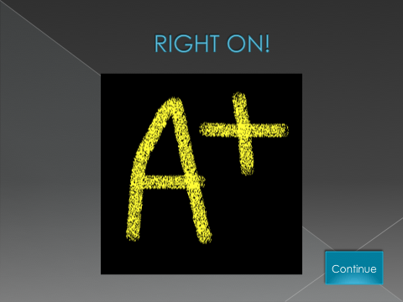

Students must take an active role in their learning in order to complete this StAIRs project. They have to take responsibility over their learning in order to complete their assignment. If my students are not taking an active role they will not be able to complete their assignment. I will be able to assess my students based on the completion of the project as well as their ability to use the information in their future writing.
My overall goal was to create a student lead project that would familiarize my students with the six writing traits. I want my students to understand that there are many parts that contribute to a well written paper and it is important to think about each trait when writing. I also wanted to my students to be engaged when they are participating during the StAIRs.
I feel that I created a project that provides students information regarding the proper steps to undergo when writing. I also feel that I was able to create a project that contained consistency when presenting the information.
As I am reviewing my StAIRs project I see that I would added to my project to create more questions after each trait. It would have also added to my project to create higher level thinking questions. If I added higher level Blooms questions my students would be asked to not only state the definitions of different traits, but also give examples and apply this information to their own work. I will have to explore in the future how to incorporate open ended questions to my project. This may entail my students doing written work when they are at the computer completing the writing traits StAIR.
This StAIR project is for a re-teaching lesson that follows what my students have already leaned in their previous English classes. The assessment for my students learning is not concrete. I would assess my students on their ability to complete the StAIR as well as their ability to communicate in a whole group setting as to what they learned. Assessment is an area of my project that I need to revisit. It is not clearly stated and my students may be confused.
A suggestion that I was provided with from a coworker was to use a some objects that move to gain my students attention and make the project more fun to complete. I was also given the suggestion to create more slides for describing each trait. That way I would be able to provide more examples and hopefully get my students thinking about how they can use these traits in their writing.
Now, that I am able to reflect on my project I will be able to improve my work to make it more meaningful for my students. Once I have students participate in this project I will be able to ask for their feedback. From this feedback I will be able to modify the project to enhance the learning of my students.

